Project Interim Progress Report
(Rapport d’avancement de project intérimaire)
February 1, 2017 – June 30, 2017
Please submit by April 28, 2017
(Attn: Joanne O’Connor management@nserc-canrimt.org)

Instructions
This progress report, updated milestones and the Form 300 are required as a condition of research funding support from the sponsors of the NSERC CANRIMT. Please report for activity in the current reporting period only.

SUMMARY

THEME IV: Adaptive Tooling/Processes & Novel Manufacturing Processes/Applications |  |  |  |  |  | Leader/ Chef:  (Veldhuis, McMaster)
PROJECT IV.C.12: Investigation of Wear Performance during Machining of Ni-based Aerospace Alloy |  |  |  |  |  | Leader/ Chef:  (Veldhuis, McMaster)
PROJECT DURATION/DURÉE DU PROJET : 4 years
STATUS/STATUT: (Milestones to be updated by each Project Leader)
Ahead of Schedule |  | On Schedule | X | Delayed |  |  | Cancelled

PROJECT DESCRIPTION/ DESCRIPTION DU PROJECT
(Brief description in point form, including role of project in Theme.)
- This project will focus on the unique challenges associated with high temperature Ni-based alloys, using an approach similar to that described in IV.C.11.
- Coatings and other surface treatments, such as texturing of cutting tools as outlined in IV.C.10, have shown significant benefits for these applications but, based on Phase 1 testing, there are opportunities for additional improvement.
- Thus this research project will investigate the wear behaviour of various coated carbide and uncoated ceramic cutting tools under different machining conditions during cutting of Ni-based superalloys.
- This will emphasise specific surface/interface phenomena taking place during cutting this material under high performance conditions.
- The research is aimed at improving productivity and surface integrity through process optimization, heavily leveraging the virtual machining environment developed in Phase 1.

PROJECT OBJECTIVES & METHODOLOGY/ OBJECTIFS DU PROJET & MÉTHODOLOGIE
(Include alignment with Network objectives.)
The main objective of this project is to improve the machinability of Ni-based alloys which are considered as difficult-to-cut materials by improving the tribological properties of the machining process through applying proper multilayer coatings.
The project will result in better understanding the different phenomena happening at tool-chip interface under different cutting conditions. The results will contribute to optimization of the process and improve the overall machinability of the Ni-based alloys.

1. RESEARCH TEAM/ ÉQUIPE DE RECHERCHE
(Summary for the current reporting period)
1a: Research Personnel (Supervisors, Co-Supervisors, Collaborators)/
Personnel de recherche
Name, given name/  Nom., prénom | Organization/  Organisation | Sup./Co-Sup./  Collaborator | E-mail/Courriel | Phone No./  Téléphone
Stephen C. Veldhuis | McMaster | Sup. | veldhu@mcmaster.ca | 905 525 9140  Ext. 27044
Marek Balazinski | Polytechnique Montreal | Collaborator | marek.balazinski@polymtl.ca | 514 340 4711  Ext. 4015

1b: Students, Postdoctoral Fellows, Research Assist./
Assoc./Eng., Technical/Professional, Guests (from outside Ontario; from outside Canada)/
Étudiants, Boursier de recherches postdoctorales, assistants, techniciens et invites (invite hors Ontario; hors Canada)

Name, given name/  Nom., prénom | Position | Organization/  Organisation | Name/Nom.  (S) or /ou (C)* | Start/  Début | End/ Fin | CANRIMT Salary/Mo  incl ben. | Extern.  funding  amount | Extern  funding  source
Saharnaz Montazeri | PhD Student | McMaster | Stephen C. Veldhuis (S) | Jan  2017 | Jan 2021 | 1340 | 100 | SONAMI  (FedDev)
Maryam Aramesh | PDF | McMaster | Stephen C. Veldhuis (S) | Oct  2015 |  | 4166 | 843 | SONAMI  (FedDev)
German Fox-Rabinovich | Research  Associate | McMaster University | Stephen C. Veldhuis (S) | Mar  2003 |  | 5333 | 5310 | SONAMI  (FedDev)
*(S) – Supervisor
(C) – Co-Supervisor

TOTAL # | BASc | MASc/  M.Eng. | Ph.D. | PDF | Res. Asst. | Res. Assoc. | Res. Eng. | Tech./ Prof. | Guests/  outside Ontario | Guests/  outside Canada
3 |  |  | 1 | 1 |  | 1

1c: Partners & Contributions/
Partenaires et Contributions

Organization /  Organisation | Acronym/  Acronyme | Contact | Cash/  Espèce | In-Kind/ Nature | Overhead/  Frais généraux | Total
Honda  McMaster-Veldhuis Projects |  | Mark Earle | 120,000 | 152,500 | 30,000 | 150,000

2. RESEARCH PLAN FOR THE CURRENT PERIOD/PLAN DE RECHERCHE POUR
LA PÉRIOD ACTUELLE (Please list both the technical objectives, methodologies and milestones as stated in the previous report.)
- Participating in the orientation training offered by McMaster.
- Passed the “Manufacturing Process I course.
- Literature review is undergoing.
- Completed the trainings including safety trainings and some technical trainings such as machine shop trainings, SEM and EDS.
- Started the preliminary tests with uncoated carbide tools with Inconel 718 and Al-Si.

3. ALIGNMENT OF RESEARCH PROJECT WITH NETWORK OBJECTIVES/
ALIGNEMENT DU PROJET DE RECHERCHE AVEC LES OBJECTIFS DU RÉSEAU
( Please comment on the alignment of the research project with the overall Network objectives.)
- Improving the overall machinability of Ni-based alloys, using proper tooling
- Optimizing the machining processes resulting in optimum tool life and surface integrity
- Investigating the performance of different coated ceramic tools under different cutting conditions and establish the data required for the modeling process.

.

4. PROBLEMS and RESOLUTIONS/ PROBLEMES ET SOLUTIONS PROPOSÉES
( Please summarize any problems arising during the current reporting period and their resolution or plans for resolution.)
Problem/ Problème:

Resolution / Résolution:

5. RESEARCH PROGRESS and RESULTS/ PROGRÈS DE LA RECHERCHE et RESULTATS:
(Summarize progress and results below.)

5a: MILESTONES/ÉTAPES
Summarize progress on milestones – including % completed – as outlined in the Research Plan for the current reporting period and any modifications since the last reporting period. (Milestones document also to be updated for each project.)
MILESTONE/ ÉTAPE: Literature review
Progress: The literature review has been started and is progressing well.
Modifications:
% Completed/ Rempli | 15%
MILESTONE/ ÉTAPE: Detailed coating development and optimization
Progress: Not started
Modifications:
% Completed/ Rempli | 0%
MILESTONE/ ÉTAPE: Bench top testing
Progress: The primary test has been started
Modifications: -
% Completed/ Rempli | 25%
MILESTONE/ ÉTAPE: Lab scale machinability testing
Progress: Not started
Modifications: -
% Completed/ Rempli | 0%
MILESTONE/ ÉTAPE: Production Scale Testing Conclusion, technology transfer and publication
Progress: Not started
Modifications: -
% Completed/ Rempli | 0%
MILESTONE/ ÉTAPE: Conclusion, technology transfer and publication
Progress: Not started
Modifications: -
% Completed/ Rempli | 0%

5b: PUBLICATIONS and PRESENTATIONS/ PUBLICATIONS ET PRESENTATIONS
Please list all publications directly arising from Network-funded research during the current period. Do not include abstracts.

A: REFEREED CONTRIBUTIONS - ARTICLES
Include articles in refereed publications – please specify whether the article has been submitted (S), accepted (A) or published (P).
Last Name, Initial | Year | Title, Journal, Volume | Status
B: REFEREED CONTRIBUTIONS - OTHER
Include papers in refereed conference proceedings, letters, notes, communications, review articles, monographs, books, book chapters and government publications.
Last Name, Initial | Year | Description | Status
 |  | Conference Title, Location and Date (Status: Invited, Not invited)
 |  | Journal/Book/Publication Title (Status: S-submitted; A-accepted; P-published)
C: NON-REFEREED CONTRIBUTIONS
Include papers in non-refereed conference proceedings, papers, letters and review articles.
Last Name, Initial | Year | Description
 |  | Conference Title, Location and Date
 |  | Journal/Book/Publication Title
D: SPECIALIZED PUBLICATIONS - PRESENTATIONS
Include theses, presentations, industrial/technical reports, internal reports, discussions of abstracts and symposium records.
Last Name, Initial | Year | Description
 |  | Thesis or Conference Title, Location and Date
 |  | Journal/Book/Publication Title
E: PUBLICATIONS –
Not originally funded by NSERC CANRIMT but continuing or completed with Network funding
Last Name, Initial | Year | Description/Title (include start date of NSERC CANRIMT funding)
F: PUBLICATIONS –
Not funded by NSERC CANRIMT but related to the Network research focus
Last Name, Initial | Year | Description/Title

5c: PATENTS and LICENSES/ BREVETS ET LICENSES
Non-disclosure agreements signed, patent applications filed, patents issued, copyrights, licenses under negotiation, licenses granted, etc.

Category | Owner | Description

5d: OTHER COMMUNICATIONS, AWARDS/ AUTRES COMMUNICATIONS, PRIX
Provide information on additional communications related to your work, such as awards and distinctions, news stories, interviews, public forums, press releases, etc. for the current reporting period (please provide copies or links.)
Name, given name/  Nom, prénom | Details | Date | Link or copy attached

6. TRAINING/ FORMATION
(Describe the extent of cross-network and partner involvement in training for the current reporting period.)
- MMRI industry partners have been supplying materials for initial testing and to establish benchmark conditions.

7. RESEARCH PLAN FOR NEXT 6 MONTHS/ PLAN DE RECHERCHE POUR LES 6 PROCHAINS MOIS (Describe Planned Research Activities for the next 6 month period and include any modifications made during the current reporting period.); also please list both the technical objectives and milestones.)
- Continuing the literature review.
- Completing the XRD training.
- Assessing the feasibility of a new method for preventing chipping during machining of Inconel 718.

8. OPTIONAL – Comments, Questions and/or Feedback/
OPTION – Commentaires, questions et/ou des commentaires
Include any supplemental comments or questions pertaining to the Network here.
This project was started early to meet the needs of our industry partner and converted from a MASc to a PhD project based on the research background of Dr. Maryam Aramesh and the fact that Saharnaz Montazeri joined the team.

9. NETWORK EVENTS ATTENDED or SUGGESTIONS /
ÉVÉNEMENTS RÉSEAU ONT ASSISTÉ ou SUGGESTIONS

Please list any Network-related events attended and include comments and suggestions for events which may be helpful and informative for Network members to attend in future.
Event | Comments/Suggestions
MMRI Industry Open House

Progress:

July 1 - Jan. 31, 2016
As the first step, uncoated carbide tools was investigated under different cutting conditions. Thus, a benchmark will be established for the further investigations. The preliminary tests were started and are undergoing. Inconel 718 is used as a working material and uncoated tungsten carbide insert k313 is used as the tool. The experiment set-up is shown in Figure 1.
Sequential machining tests were performed under different cutting conditions. After each test, feed, radial and cutting forces were measured with the dynamometer and also the tool wear was investigated using an optical microscope. In all the conditions, tools were chipped only after a few steps. An example of a chipped tool is shown in Figure 2. As the next step, machining tests will be performed with different coated tools. Detailed investigations including mechanical testing and microstructural analysis will be performed on the worn tools to see the effect of different coatings on the tool wear mechanisms.

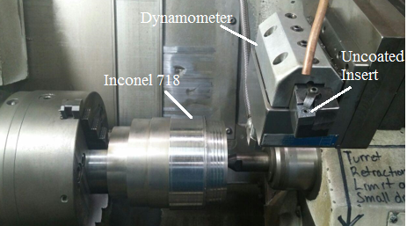
Figure 1- Experimental set-up.

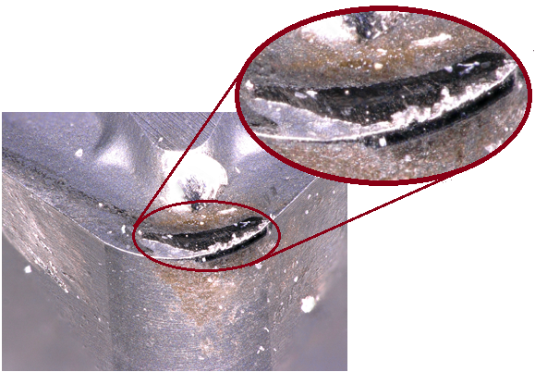
Figure 2- An example of a worn tool after machining of Inconel 718.

Feb. 1 – June 30, 2017
The preliminary machining tests with the uncoated carbide tool is completed. The optimum cutting conditions is identified. The required trainings for the study of dominant wear mechanisms were completed. The investigations are to be continued. In addition, new coating and post treatments will be tested. Figure3 shows the cross section of the worn tool during machining of Inconel 718 with cutting speed of 50 mm/min, feed rate of 0.1mm/rev and depth of cut of 0.15 mm. The image is taken using Alicona microscope.
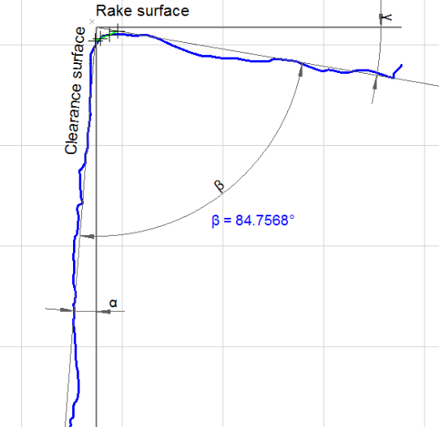
Figure 3- Cross section of worn tool at V= 50, f= 50 0.1mm/rev and depth of cut of 0.15 mm

