Project Interim Progress Report
(Rapport d’avancement de project intérimaire)
February 1, 2017 – June 30, 2017
Please submit by April 28, 2017
(Attn: Joanne O’Connor management@nserc-canrimt.org)

Instructions
This progress report, updated milestones and the Form 300 are required as a condition of research funding support from the sponsors of the NSERC CANRIMT. Please report for activity in the current reporting period only.

SUMMARY

THEME IV: Adaptive Tooling/Processes & Novel Manufacturing Processes/Applications |  |  |  |  |  | Leader/ Chef:  (Veldhuis, McMaster)
PROJECT IV.A.1:Tool Geometry, Edge & Wear Measurement & Processing Conditions |  |  |  |  |  | Leader/ Chef:  (Veldhuis, McMaster)
PROJECT DURATION/DURÉE DU PROJET : 2 years
STATUS/STATUT: (Milestones to be updated by each Project Leader)
Ahead of Schedule |  | On Schedule | X | Delayed |  |  | Cancelled

PROJECT DESCRIPTION/ DESCRIPTION DU PROJECT
(Brief description in point form, including role of project in Theme.)
- At the heart of the tool development program is the measurement of the tool’s cutting edge geometry.
  - needed to establish its impact on the cutting process mechanics
  - measure the tool wear rate and assess the failure mechanisms (IV.A.2).
- This project will also need to consider process conditions in establishing wear mechanisms.
  - With this knowledge engineered surfaces can be proposed and produced to mitigate observed wear and enhance tool performance.
- A repeatable method for measuring tool geometry, cutting edge features and chip breaker designs for a wide range of tool geometries and processes is needed to assess the tool condition before going into service.
  - As the tool wears, a quick and reliable method of assessing the main modes of wear is also needed.
  - The system must be able to record images and track wear rate by measuring critical linear distances such as flank wear, crater diameter and notch depth.
  - Values need to be assigned for volume of cutting edge change, flank volume, crater and notch, and methods for assessing surface and subsurface damage (crack formation) and residual stress should also be explored.
    - This data must be related to the results in IV.B. as part of the tool selection/development framework and be used specifically by researchers working on IV.B.3 and IV.B.4.
  - Tools that have been processed (rake face polishing and edge preparation) using the novel non-Newtonian fluid processing approach to be developed as part of project IV.D.1 will also be characterized in this project.
- This geometry data needs to be organized to be provided to Finite Element (FE) models of machining to improve the relevance of these models for specific machining processes.

PROJECT OBJECTIVES & METHODOLOGY/ OBJECTIFS DU PROJET & MÉTHODOLOGIE
(Include alignment with Network objectives.)
- Develop a method for characterizing the conditions underling tool wear including cutting edge geometry of the tool and the local conditions such as temperature and load.
  - Advanced microscopy will be used to measure the cutting edge. Better methods for defining tool wear and describing its progression over the life of the tool will also be developed.
- Numerical modeling methods will be used as a non-destructive method to estimate local conditions in the cutting zone for a specific tool edge geometry including edge preparation, chip breakers and tool wear.
- Cutting tests will be done to assess the influence of different tool geometries including edge preparation (hone, chamfer, chamfer with hone), chip breakers and different levels of tool wear (develop better ways to characterize tool wear) when cutting various materials.
- Accurate cutting edge geometries will be provided to the FE analysis to improve the model of cutting force and temperature and chip formation. The chip formation prediction ability of the FE models will be enhanced for use in process development and optimization. A data base will be developed which will be used for parameter selection for different combination of workpiece-tool materials.
- Integrated procedures for optimizing the machining process will also be explored combining tool design, coating selection and machining conditions.

1. RESEARCH TEAM/ ÉQUIPE DE RECHERCHE
(Summary for the current reporting period)
1a: Research Personnel (Supervisors, Co-Supervisors, Collaborators)/
Personnel de recherche
Name, given name/  Nom., prénom | Organization/  Organisation | Sup./Co-Sup./  Collaborator | E-mail/Courriel | Phone No./  Téléphone
Stephen C. Veldhuis | McMaster | Sup. | veldhu@mcmaster.ca | 905 525 9140  Ext. 27044
Philip Koshy | McMaster | Co-Sup | koshy@mcmaster.ca | 905 525-9140  Ext. 27833

1b: Students, Postdoctoral Fellows, Research Assist./
Assoc./Eng., Technical/Professional, Guests (from outside Ontario; from outside Canada)/
Étudiants, Boursier de recherches postdoctorales, assistants, techniciens et invites (invite hors Ontario; hors Canada)

Name, given name/  Nom., prénom | Position | Organization/  Organisation | Name/Nom.  (S) or /ou (C)* | Start/  Début | End/ Fin | CANRIMT Salary/Mo  incl ben. | Extern.  funding  amount | Extern  funding  source
Ardalan Emamian | M.A.Sc. | McMaster University | Stephen C. Veldhuis (S) | Sep 2015 | Sep  2017 | 1166
Baoqin (Sophia) Deng | M.A.Sc. | McMaster University | Stephen C. Veldhuis (S) | Jan 2017 | Dec 2018 | 1282 | 317 | SONAMI  (FedDev)
Maryam Aramesh | PDF | McMaster University | Stephen C. Veldhuis (S) | Oct  2015 |  | 4166 | 843 | SONAMI  (FedDev)
German Fox-Rabinovich | Research  Associate | McMaster University | Stephen C. Veldhuis (S) | Mar  2003 |  | 5333 | 5310 | SONAMI  (FedDev)
*(S) – Supervisor
(C) – Co-Supervisor

TOTAL # | BASc | MASc/  M.Eng. | Ph.D. | PDF | Res. Asst. | Res. Assoc. | Res. Eng. | Tech./ Prof. | Guests/  outside Ontario | Guests/  outside Canada
4 |  | 2 |  | 1 |  | 1

1c: Partners & Contributions/
Partenaires et Contributions

Organization /  Organisation | Acronym/  Acronyme | Contact | Cash/  Espèce | In-Kind/ Nature | Overhead/  Frais généraux | Total
Honda  McMaster-Veldhuis Projects |  | Mark Earle | 120,000 | 152,500 | 30,000 | 150,000

2. RESEARCH PLAN FOR THE CURRENT PERIOD/PLAN DE RECHERCHE POUR
LA PÉRIOD ACTUELLE (Please list both the technical objectives, methodologies and milestones as stated in the previous report.)
- Ardalan, the student working on the FE analysis has completed the required safety training, machine shop training and his graduate courses have been completed and the student is now working on improving the FE model.
- Refinements to the FE model are being done to allow for the inclusion of actual tool geometries and tool – workpiece friction properties.
- A comprehensive study is being conducted in the area of virtual machining, cutting process simulation and tool path optimization.
- Literature survey is almost completed and the last remaining course is passed
- Tool wear measurements using the new microscopes is undergoing.
- Methods are being developed for measuring tool edge geometry, chip breakers and quantifying tool wear and organize this data to support the FE modeling.
- A 2D FE model which can capture important features such as temperature and force profile, using actual tool geometries were developed
- Modeling the tool wear is under investigation.
- Sophia was completing her basic orientation in the lab, which includes safety training, machine shop training and has started her graduate courses.
- She will also be gaining familiarity with our new optical microscopes and using them to measure and quantify edge geometry. In the future this data will be supplied to Ardalan for use in his FE models.
- Completed the basic orientation in the lab, which includes safety training, machine shop training and 2 graduate courses.
- Have been trained with our new optical microscopes and using them to measure and quantify edge geometry, wear mechanism and wear data collecting. This data will be supplied to Ardalan for use in his FE models.

- Literature survey related to tool geometry and tool wear is in progress.

3. ALIGNMENT OF RESEARCH PROJECT WITH NETWORK OBJECTIVES/
ALIGNEMENT DU PROJET DE RECHERCHE AVEC LES OBJECTIFS DU RÉSEAU
( Please comment on the alignment of the research project with the overall Network objectives.)
Tool wear is one of the most important factors affecting the productivity of any manufacturing process. The goal of this research project is to obtain a better understanding of the effect of different tool geometries and features on tool wear and to develop methods for tool wear assessment.
The tool data will be used as an input for the FE model of the cutting process which will be further applied to realize an integrated method of tool geometry and wear characterization that incorporates the development of a digital model of the machining process.

4. PROBLEMS and RESOLUTIONS/ PROBLEMES ET SOLUTIONS PROPOSÉES
( Please summarize any problems arising during the current reporting period and their resolution or plans for resolution.)
Problem/ Problème:
Previously it was difficult to fully measure cutting edge geometries and quantify tool wear.

Resolution / Résolution:
The MMRI has now purchased two new microscopes which use new optical capabilities to quantify tool geometries including edge preparation, chip breakers and wear.

5. RESEARCH PROGRESS and RESULTS/ PROGRÈS DE LA RECHERCHE et RESULTATS:
(Summarize progress and results below.)

5a: MILESTONES/ÉTAPES
Summarize progress on milestones – including % completed – as outlined in the Research Plan for the current reporting period and any modifications since the last reporting period. (Milestones document also to be updated for each project.)
MILESTONE/ ÉTAPE: Literature review
Progress: Study includes basic physics of machining, tool edge geometries, wear and measurement methods as well as theory of Finite Element (FE) analysis and its specific application in machining as a numerical solution for prediction of cutting physical parameters.
Modifications:
% Completed/ Rempli | 70%

MILESTONE/ ÉTAPE: Integrate hardware and define procedures for measuring tool geometry and cutting edge
Progress: The MMRI Lab is now equipped with modern microscopes which are capable of measuring the 3D features which make up the cutting edge and describe wear.
Modifications:
% Completed/ Rempli | 40%

MILESTONE/ ÉTAPE: Establish standards for assessing and tracking tool wear over time and relating these to process conditions
Progress: Tool geometry measurement is started and methods for describing it and suppling the data to the FE analysis is under investigation.
Modifications:
% Completed/ Rempli | 40%

MILESTONE/ ÉTAPE: Lab-scale testing and analysis on available tooling in the lab and with our industry partners
Progress: Not started
Modifications:
% Completed/ Rempli | 0%

MILESTONE/ ÉTAPE: Develop standard procedures for a wide range of tool geometries and processes for use in other projects and prepare publications
Progress: A conference paper is submitted to VMPT 2017.
Modifications:
% Completed/ Rempli | 30%

5b: PUBLICATIONS and PRESENTATIONS / PUBLICATIONS ET PRESENTATIONS
Please list all publications directly arising from Network-funded research during the current period. Do not include abstracts.

A: REFEREED CONTRIBUTIONS - ARTICLES
Include articles in refereed publications – please specify whether the article has been submitted (S), accepted (A) or published (P).
Last Name, Initial | Year | Title, Journal, Volume | Status
Ardalan Emamian, Stephen C. Veldhuis, Eugene Ng | 2017 | Cutting tool selection in machining based on finite  element simulation results | (A)
B: REFEREED CONTRIBUTIONS - OTHER
Include papers in refereed conference proceedings, letters, notes, communications, review articles, monographs, books, book chapters and government publications.
Last Name, Initial | Year | Description | Status
 |  | Conference Title, Location and Date (Status: Invited, Not invited)
 |  | Journal/Book/Publication Title (Status: S-submitted; A-accepted; P-published)
C: NON-REFEREED CONTRIBUTIONS
Include papers in non-refereed conference proceedings, papers, letters and review articles.
Last Name, Initial | Year | Description
 |  | Conference Title, Location and Date
 |  | Journal/Book/Publication Title
D: SPECIALIZED PUBLICATIONS - PRESENTATIONS
Include theses, presentations, industrial/technical reports, internal reports, discussions of abstracts and symposium records.
Last Name, Initial | Year | Description
 |  | Thesis or Conference Title, Location and Date
 |  | Journal/Book/Publication Title
E: PUBLICATIONS –
Not originally funded by NSERC CANRIMT but continuing or completed with Network funding
Last Name, Initial | Year | Description/Title (include start date of NSERC CANRIMT funding)
F: PUBLICATIONS –
Not funded by NSERC CANRIMT but related to the Network research focus
Last Name, Initial | Year | Description/Title

5c: PATENTS and LICENSES/ BREVETS ET LICENSES
Non-disclosure agreements signed, patent applications filed, patents issued, copyrights, licenses under negotiation, licenses granted, etc.

Category | Owner | Description

5d: OTHER COMMUNICATIONS, AWARDS/ AUTRES COMMUNICATIONS, PRIX
Provide information on additional communications related to your work, such as awards and distinctions, news stories, interviews, public forums, press releases, etc. for the current reporting period (please provide copies or links.)
Name, given name/  Nom, prénom | Details | Date | Link or copy attached

6. TRAINING/ FORMATION
(Describe the extent of cross-network and partner involvement in training for the current reporting period.)
Honda has been supplying tooling and workpiece materials for cutting tests. Once our measurement methods are in place we will be performing more testing to build up our data base relating tooling-workpiece and performance. Training on Alicona and Keyance microscopes are completed.

7. RESEARCH PLAN FOR NEXT 6 MONTHS/ PLAN DE RECHERCHE POUR LES 6 PROCHAINS MOIS (Describe Planned Research Activities for the next 6 month period and include any modifications made during the current reporting period.); also please list both the technical objectives and milestones.)
- Ardalan
- Accurate tool geometries obtained from Alicona microscope will be inputted in the model
- A methodology will be developed for tool wear prediction
- The model validation will be started
- Sophia
- Keep on literature reviewing on tool geometry and tool measurement
- Develop methods to evaluate tool wear by using optical microscope and collect wear data for analyzing, both index able tools and solid tools.
- Identify the effect of hone radius and T-land geometries on tool performance, such as surface integrity and tool life.
8. OPTIONAL – Comments, Questions and/or Feedback/
OPTION – Commentaires, questions et/ou des commentaires
Include any supplemental comments or questions pertaining to the Network here.

9. NETWORK EVENTS ATTENDED or SUGGESTIONS /
ÉVÉNEMENTS RÉSEAU ONT ASSISTÉ ou SUGGESTIONS

Please list any Network-related events attended and include comments and suggestions for events which may be helpful and informative for Network members to attend in future.
Event | Comments/Suggestions
Attend the MMRI Industry Open House

Progress:
July 1 - Jan. 31, 2016
In this study, a 2D coupled thermo-mechanical model was developed by using finite element simulation to capture stress, strain and temperature profile which are vital factors in tool wear. In a cutting operation heat is the product of friction and plastic work. In this case, it was assumed that 90% of the plastic work and the whole amount of frictional work will be converted to heat. Also 50% of the generated heat is assumed in this case to go into the work piece (AISI 1045). This study was done on different tool edge geometries including a perfectly sharp tool. Some of the screenshots of these simulation are provided below.
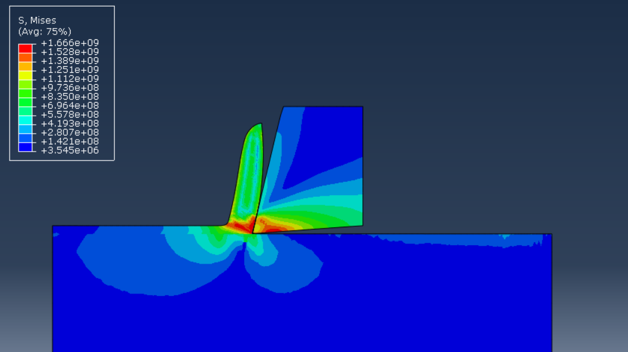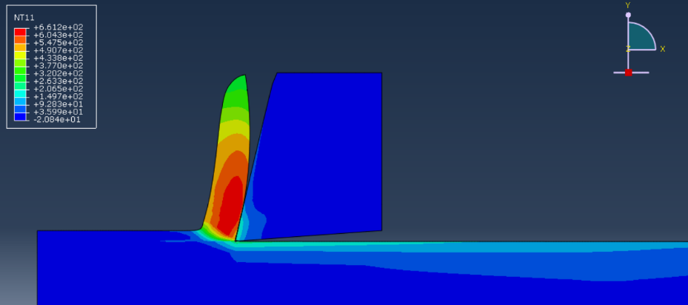
Figure 1) Stress and Temperature profile for positive rake angle

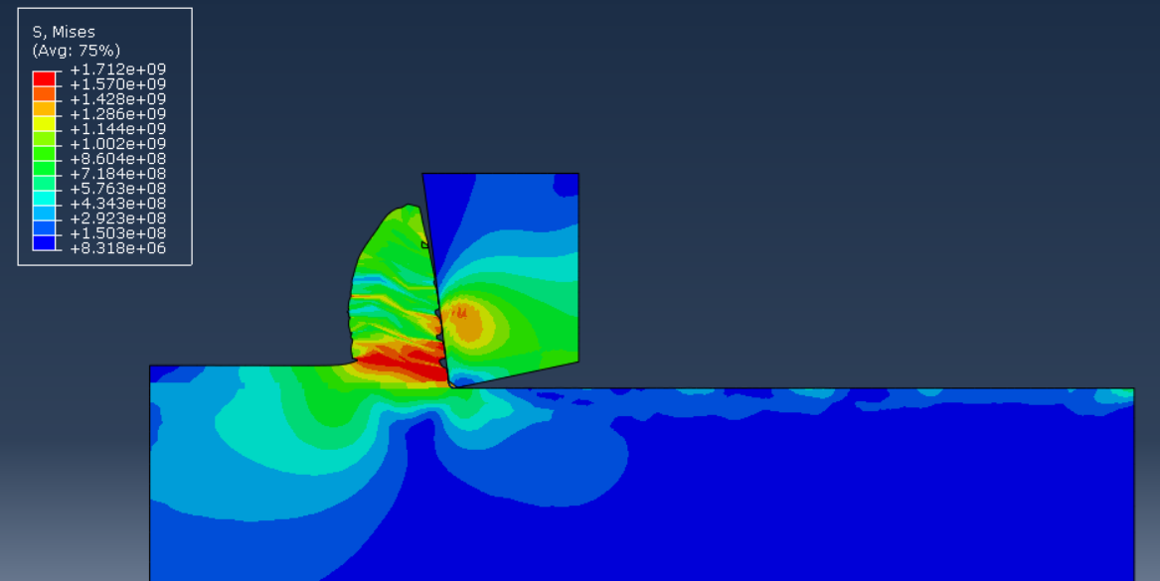
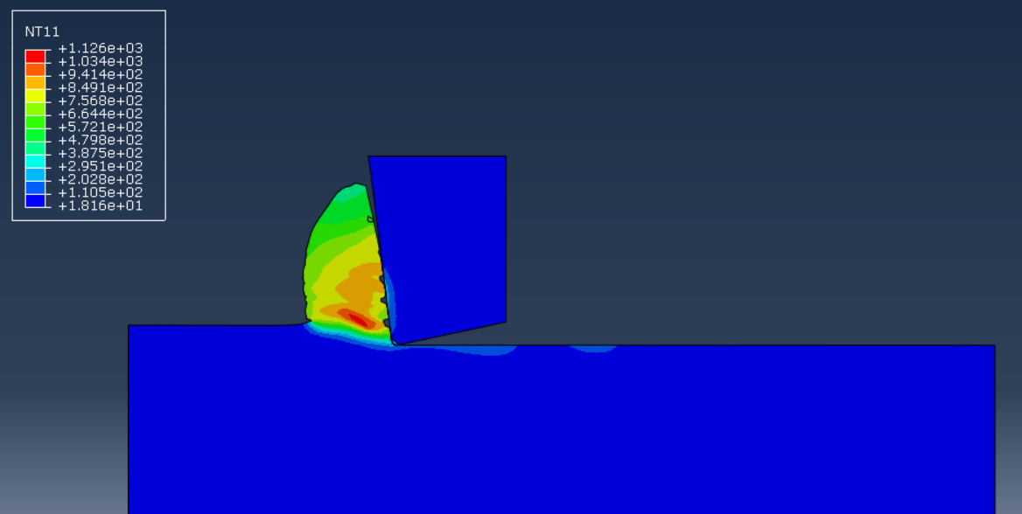
Figure 2) Stress and Temperature profile for negative rake angle

Tool wear measurement capability has also been extended in the lab and models of worn tools will be provided to the FEA analysis.

Cutting geometry plays an important role during the machining process. Wear mechanism, surface integrity, and tool life can be affected by various geometries. In order to get better tool performance, analyzing different types of geometries before machining is essential, which helps us better understand how a cutting edge works and fails. After machining, in order to make out the next plans, wear mechanism should be assessed in the first time.

- Literature review
Basic tool geometry parameters have been reviewed. Until now rake angle and clearance angle in which application they used have been understood. Larger rake angle is applied when cutting soft material, like Aluminum and low carbon steel. While it comes to hard material, small rake angle is preferred. Clearance angle prevents the friction between flank face and workpiece. Both angles should be taken into consideration before machining. The next step would be focusing on cutting forces in terms of different geometry parameters, chamfer and round edge.

2. Wear measurement
Measuring tool wear enables us to get a better understanding of machining process, what kind of wear mechanism it was and how to prevent severe damage on tools, and then figure out the way to improve tool performance. At present, I’ve learned basic operation on microscope as well as measuring wear on CBN inserts supplied by Honda. Wear mechanisms could be different on the same batch of inserts that are used in the same process due to variation in workpiece material. Deformation, built-up edge and small chipping can be observed in those inserts.

Feb. 1-Jun. 30, 2017
Ardalan
Progress
1. Tool Profile

As a preliminary step prior to wear measurement, specific new tools were chosen as benchmarks for sectional and volumetric analogy. Thus, for each wear mechanism characterization in future we will have recorded data of new tools as benchmarks and compare them with the worn tools. The figure below shows CBN tool as an example which the Alicona built-in software is able to section the tool out to as many sections as we want and average them out, and output the resultant cross area and geometry features.

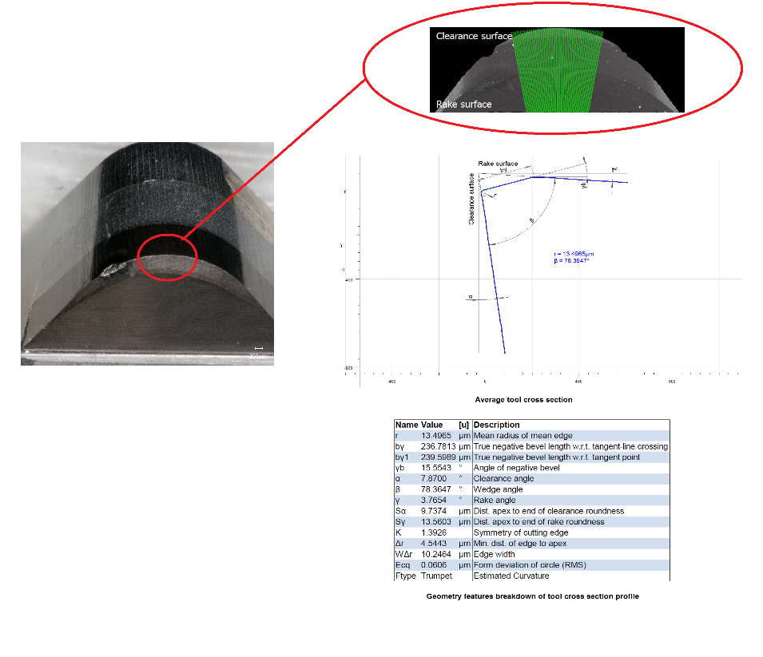
Figure 3) Average tool cross section area from Alicona

- FE Model:
After developing the preliminary model, the model was compared with the same research paper and the results of this method (Updated Lagrangian Model) was promising. As can be seen in the following table, temperature profile for six different cutting conditions were analyzed. Also cutting forces were compared between experiments and FE results.

Speed  Feed | 150(m/min) | 200(m/min) | 250(m/min) | 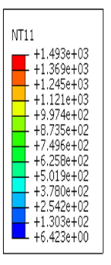
0.1(mm/rev) | 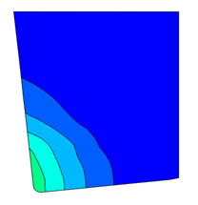 | 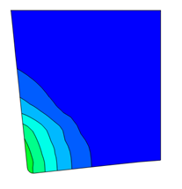 | 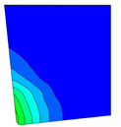
0.2(mm/rev) | 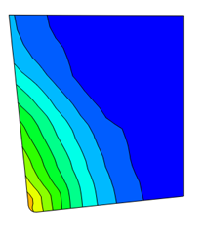 | 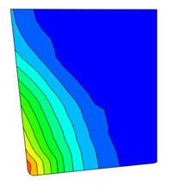 | 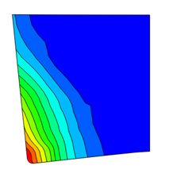

Sophia:
Progress:
- Microscope training
Using Keyence to take high quality pictures to identify tool wear mechanisms, 3D images taken by which help us better understanding the geometries and wear. What’s more, different holders enable us to measure the wear value on flank face and rake face, nose radius as well.

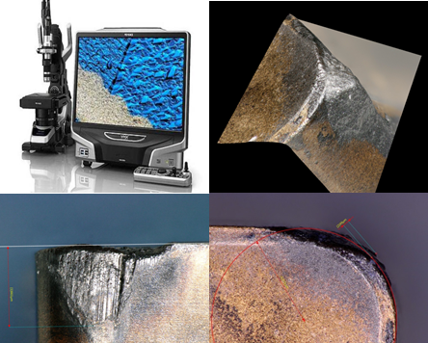

For Alicona, after the first stage training, we can get 2D profiles from sections on tools. In this way no matter new tool geometries or wear part, all of them can be assessed. Alicona will be specifically mentioned in Ardalan’s progress.

- CBN tool assessing
In the past months, several groups of CBN tools have been assessed, including solid one and welding one. From the assessment, when cutting cast iron and aluminum, the most common wear mechanisms for CBN tools are abrasive and adhesion. While for solid one, in addition to severe adhesion, serious notch wear could be seen. In order to better assessing the CBN tool wear and figure out the better way to solve the problem, the procedures of assessing right are shown below, taking pictures by Keyence, analyzing composition by SEM&EDS, 2D profiles by Alicona.

