Project Interim Progress Report
(Rapport d’avancement de project intérimaire)
February 1 – June 30, 2017
Please submit by April 28, 2017
(Attn: Joanne O’Connor management@nserc-canrimt.org)

Instructions
This progress report, updated milestones and the Form 300 are required as a condition of research funding support from the sponsors of the NSERC CANRIMT. Please report for activity in the current reporting period only.

SUMMARY

THEME III: Machining of Composite Parts |  |  |  |  |  | Leader/ Chef:  (S. Park )
PROJECT III.6: 3D Ultrasonic Vibration Tool Holder for Machining Carbon Fiber Composites |  |  |  |  |  | Leader/ Chef:  (Y. Altintas/X Lu, UBC)
PROJECT DURATION/DURÉE DU PROJET : July 1, 2016 – February 1, 2019
STATUS/STATUT: (Milestones to be updated by each Project Leader)
Ahead of Schedule |  | On Schedule | X | Delayed |  |  | Cancelled

PROJECT DESCRIPTION/ DESCRIPTION DU PROJECT
(Brief description in point form, including role of project in Theme.)
Carbon fiber-reinforced plastic (CFRP) composites have widely used in aircraft structure due to their high strength/ stiffness to weight ratio. However, the damages such as fiber pull-out and delamination occur during machining of CFRP materials. To avoid the damages, manufacturers optimized the cutting parameters including depth of cut, cutting speed, tool geometry and material based on experimental results. Some other researchers and companies designed special tools for cutting CFRP. Recently, pioneered machine tool companies, such as DMG MORI and EWI, have developed ultrasonic vibration tool holders, which can induce a small vibration (micrometer level) at tool tip with ultrasonic frequency (>= 20kHz) to create intermittent contact between tool and workpiece. They observed reduced cutting forces and delamination when ultra-sonic vibrations are delivered to the cutting zone. However, the present ultra-sonic vibrations are delivered only in one direction, which limits its use either in milling (radial) or drilling (axial).

PROJECT OBJECTIVES & METHODOLOGY/ OBJECTIFS DU PROJET & MÉTHODOLOGIE
(Include alignment with Network objectives.)
The objective of this project is to develop a 3D ultrasonic vibration tool holder, which can make vibration assisted machining general for all three axes. The proposed tool holder can be used in drilling, milling and routing CFRP. The vibration along cutting direction will decrease the cutting force by intermittent contact; and the vibration along vertical direction can help remove chip from cutting surface as well as reducing the forces in drilling direction. Figure 1 describes the structure of the proposed tool holder with a HSK interface. Piezoelectric components will be used to generate ultrasonic vibrations as transducers. Piezo Z has a ring shape to produce the Z-axis vibration by resonating the longitudinal mode. Piezo A and piezo C will work together to excite bending mode of the structure to generate vibration along X direction. The vibration along Y will be induced by piezo B and piezo D (on the back not shown in the figure) by the same principle. Currently, Z transducer has been designed and tested, and the magnitude of vibration achieves to 30µm at 28kHz without load. The transducer for XY vibration is under test. The project will include the modelling of fiber fracture and shearing with high frequency cutting edge impacts.

1. RESEARCH TEAM/ ÉQUIPE DE RECHERCHE
(Summary for the current reporting period)
1a: Research Personnel (Supervisors, Co-Supervisors, Collaborators)/
Personnel de recherche
Name, given name/  Nom., prénom | Organization/  Organisation | Sup./Co-Sup./  Collaborator | E-mail/Courriel | Phone No./  Téléphone
Altintas, Yusuf | UBC | Supervisor | altintas@mech.ubc.ca | 604-822-5622
Lu, Xiadong | UBC | Co-Supervisor | xdlu@mech.ubc.ca | 604-827-3541

1b: Students, Postdoctoral Fellows, Research Assist./
Assoc./Eng., Technical/Professional, Guests (from outside Province; from outside Canada)/
Étudiants, Boursier de recherches postdoctorales, assistants, techniciens et invites (invite hors Province; hors Canada)

Name, given name/  Nom., prénom | Position | Organization/  Organisation | Name/Nom.  (S) or /ou (C)* | Start/  Début | End/ Fin | CANRIMT Salary/Mo  incl ben. | Extern.  funding  amount | Extern  funding  source
Jian Gao | Ph.D. | UBC | Altintas (C), Xu (C) | Jul 2016 | Feb 2019
*(S) – Supervisor
(C) – Co-Supervisor

TOTAL # | BASc | MASc/  M.Eng. | Ph.D. | PDF | Res. Asst. | Res. Assoc. | Res. Eng. | Tech./ Prof. | Guests/  outside Province | Guests/  outside Canada
 |  |  | 1

1c: Partners & Contributions/
Partenaires et Contributions

Organization /  Organisation | Acronym/  Acronyme | Contact | Cash/  Espèce | In-Kind/ Nature | Overhead/  Frais généraux | Total

2. RESEARCH PLAN FOR THE CURRENT PERIOD/PLAN DE RECHERCHE POUR
LA PÉRIOD ACTUELLE (Please list both the technical objectives, methodologies and milestones as stated in the previous report.)
July 1 2016 – May 30, 2017: Prototype design of ultrasonic vibration tool holder.
June 1, 2017 – May 30, 2018: Modeling of composite fiber fracture and shear under high frequency excitation.
June 1, 2017 – February 1, 2018: Manufacturing of tool holder with ultrasonic vibration sensors.
June 1, 2018 – February 1, 2019: Composite drilling and milling tests with ultrasonic vibration assisted tool holder.
February 1, 2019 – September 30, 2019: Completion of Ph.D. thesis.

3. ALIGNMENT OF RESEARCH PROJECT WITH NETWORK OBJECTIVES/
ALIGNEMENT DU PROJET DE RECHERCHE AVEC LES OBJECTIFS DU RÉSEAU
( Please comment on the alignment of the research project with the overall Network objectives.)
It has been observed that composite machining with ultrasonic vibration assistance leads to less delamination and burr. However, there has not been any mathematical model to explain the physics behind this approach. This project will lead to development of a new, 3D ultrasonic vibrations on the tool holder. It will also focus on modeling the fatigue failure of fibers under high frequency oscillations during drilling and milling.

4. PROBLEMS and RESOLUTIONS/ PROBLEMES ET SOLUTIONS PROPOSÉES
( Please summarize any problems arising during the current reporting period and their resolution or plans for resolution.)
1) How to design a 3D ultrasonic vibration tool holder with usable amplitude.
Solution: A three-step design method is implemented including vibration mode selection, analytical calculation and FEM simulation. A prototype is built up through this method.
2) The mechanism of CFRP fracture under ultrasonic vibration influence.
Solution plan: Consider the micro-level structure failure criteria for CFRP and understand fatigue mechanism. The high frequency vibration might be the source of fatigue.
3) What is the preferred vibration frequency and amplitude for assisting CFRP cutting?
Solution plan: Modeling vibration assisted cutting process for CFRP based on the fracture mechanism studied in problem 2).

5. RESEARCH PROGRESS and RESULTS/ PROGRÈS DE LA RECHERCHE et RESULTATS:
(Summarize progress and results below.)

5a: MILESTONES/ÉTAPES
Summarize progress on milestones – including % completed – as outlined in the Research Plan for the current reporting period and any modifications since the last reporting period. (Milestones document also to be updated for each project.)

MILESTONE/ ÉTAPE:
Progress:

During this reporting period, a 3D ultrasonic vibration tool holder prototype is designed, fabricated and tested. Figure 1 shows the conceptual design of the tool holder. The tool holder includes piezoelectric transducers (piezo A, B, C, D, Z), which generate high frequency (>20kHz) vibrations along three axes from electric power, and a horn, which can amplify vibrations generated by piezo transducers. To enlarge the vibration amplitude further, the tool holder need to work at resonance frequencies. A three-step design procedure is implemented. First, the vibration modes are selected. In current design, the 2nd longitudinal mode of the tool holder is excited through a two-piece piezo stack to generate vibration along Z axis. A pair of piezo plates with 180˚ angular distance is assembled on the side surface of the tool holder in order to produce vibrations along X or Y direction. Second, the basic geometry (length, diameter and shape) of horn, which merge three axes vibrations, are solved by beam equations for longitudinal mode and bending mode. Then we use finite element method software (COMSOL) to check resonance frequencies and adjust the parameters before fabrication. Figure 2 shows the existing prototype including transducers for 3-axis vibration and a dummy tool. The vibration along Z at tool tip can achieve 22μm peak to peak amplitude at 28.6kHz with 160V_{pp} voltage input, and the vibration amplitude along X or Y is 7μm at 31.2kHz. The Z transducer can generate 70N force with 50W power, and X/Y transducer can generate 20N force with 15W power.

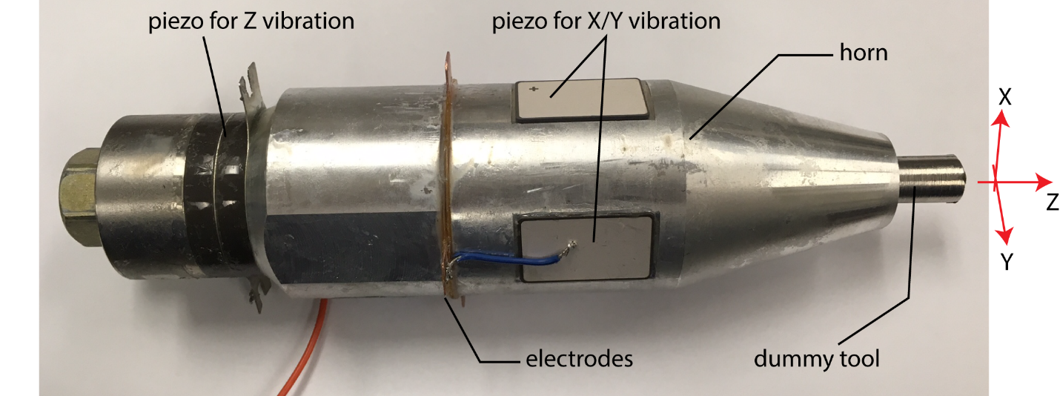
Figure 2. 3D ultrasonic vibration tool holder prototype.

% Completed/ Rempli
Tasks | % Completed
Prototype design of ultrasonic actuator | 80

5b: PUBLICATIONS and PRESENTATIONS / PUBLICATIONS ET PRESENTATIONS
Please list all publications directly arising from Network-funded research during the current period. Do not include abstracts.

A: REFEREED CONTRIBUTIONS - ARTICLES
Include articles in refereed publications – please specify whether the article has been submitted (S), accepted (A) or published (P).
Last Name, Initial | Year | Title, Journal, Volume | Status
B: REFEREED CONTRIBUTIONS - OTHER
Include papers in refereed conference proceedings, letters, notes, communications, review articles, monographs, books, book chapters and government publications.
Last Name, Initial | Year | Description | Status
 |  | Conference Title, Location and Date (Status: Invited, Not invited)
 |  | Journal/Book/Publication Title (Status: S-submitted; A-accepted; P-published)
C: NON-REFEREED CONTRIBUTIONS
Include papers in non-refereed conference proceedings, papers, letters and review articles.
Last Name, Initial | Year | Description
 |  | Conference Title, Location and Date
 |  | Journal/Book/Publication Title
D: SPECIALIZED PUBLICATIONS - PRESENTATIONS
Include theses, presentations, industrial/technical reports, internal reports, discussions of abstracts and symposium records.
Last Name, Initial | Year | Description
 |  | Thesis or Conference Title, Location and Date
 |  | Journal/Book/Publication Title
E: PUBLICATIONS –
Not originally funded by NSERC CANRIMT but continuing or completed with Network funding
Last Name, Initial | Year | Description/Title (include start date of NSERC CANRIMT funding)
F: PUBLICATIONS –
Not funded by NSERC CANRIMT but related to the Network research focus
Last Name, Initial | Year | Description/Title

5c: PATENTS and LICENSES/ BREVETS ET LICENSES
Non-disclosure agreements signed, patent applications filed, patents issued, copyrights, licenses under negotiation, licenses granted, etc.

Category | Owner | Description

5d: OTHER COMMUNICATIONS, AWARDS/ AUTRES COMMUNICATIONS, PRIX
Provide information on additional communications related to your work, such as awards and distinctions, news stories, interviews, public forums, press releases, etc. for the current reporting period (please provide copies or links.)
Name, given name/  Nom, prénom | Details | Date | Link or copy attached

6. TRAINING/ FORMATION
(Describe the extent of cross-network and partner involvement in training for the current reporting period.)
February 1 – September 30, 2019: Completion of Ph.D. Thesis

7. RESEARCH PLAN FOR NEXT 6 MONTHS/ PLAN DE RECHERCHE POUR LES 6 PROCHAINS MOIS (Describe Planned Research Activities for the next 6 month period and include any modifications made during the current reporting period.); also please list both the technical objectives and milestones.)
1) Orthogonal cutting tests for CFRP with this vibration tool holder will be conducted to collect cutting force data.
2) Study the ultrasonic vibration impacted fracture mechanism for CFRP.
3) An ultrasonic vibration tool holder with CNC machine interface for milling and drilling tests will be fabricated based on the prototype.

8. OPTIONAL – Comments, Questions and/or Feedback/
OPTION – Commentaires, questions et/ou des commentaires
Include any supplemental comments or questions pertaining to the Network here.

9. NETWORK EVENTS ATTENDED or SUGGESTIONS /
ÉVÉNEMENTS RÉSEAU ONT ASSISTÉ ou SUGGESTIONS

Please list any Network-related events attended and include comments and suggestions for events which may be helpful and informative for Network members to attend in future.
Event | Comments/Suggestions

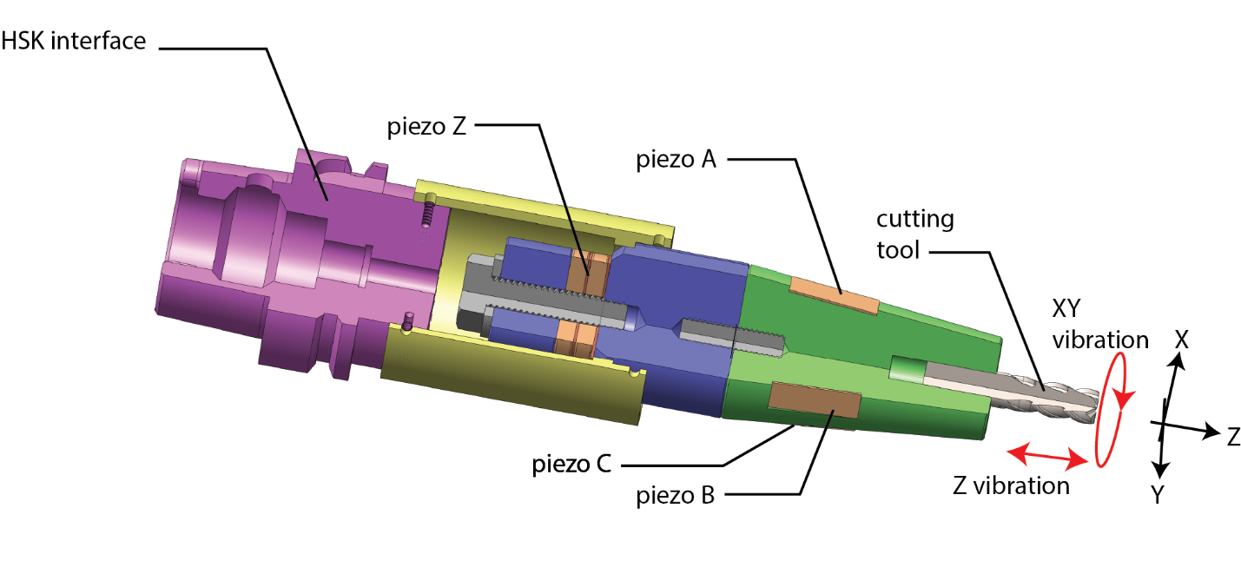Figure 1. 3D ultrasonic vibration tool holder

