## Project Interim Progress Report (Rapport d’avancement de project intérimaire) July 1, 2016 - January 31, 2017 Please submit by January 16, 2017 (Attn: Joanne O’Connor [management@nserc-canrimt.org](mailto:management@nserc-canrimt.org))

## Instructions

*This progress report, updated milestones**and the Form 300 are required as a condition of research funding support from the sponsors of the NSERC CANRIMT.* ***Please report for activity in the current reporting period only.***

**SUMMARY**

|  |  |  |  |  |  |  |  |  |
| --- | --- | --- | --- | --- | --- | --- | --- | --- |
| **THEME II : Virtual Model –Assisted Machining Monitoring and Control** | | | | | | **Leader/ Chef:**  *(R. Mayer,* École Polytechnique*)* | | |
| **PROJECT II.A.1:** ***Embedded Sensory Systems for Intelligent Machining*** | | | | | | **Leader/ Chef:**  *(Y. Altintas, UBC)* | | |
| **PROJECT DURATION/DURÉE DU PROJET : July 1, 2016 to June 2021** | | | | | | | | |
| **STATUS/STATUT:** *(****Milestones*** *to be updated by each Project Leader)* | | | | | | | | |
| **Ahead of Schedule** |  | **On Schedule** | **X** | **Delayed** |  | | **Cancelled** |  |

|  |
| --- |
| **PROJECT DESCRIPTION/ DESCRIPTION DU PROJECT**  (*Brief description in point form, including role of project in Theme.)* |
| The cutting forces in 5 axis machining will be predicted from spindle integrated, piezo electric based force sensors. The distortion of cutting forces by the structural dynamics of the spindle system will be compensated by designing an extended Kalman Filter. |

|  |
| --- |
| **PROJECT OBJECTIVES & METHODOLOGY/ OBJECTIFS DU PROJET & MÉTHODOLOGIE**  *(Include alignment with Network objectives.)* |
| Current force sensors are suitable only for laboratory use, and they cannot be used on industrial machines. The objective of his project is to install the sensors inside the spindle structure without reducing the stiffness while compensating the distortions caused by the structure’s dynamics. An extended Kalman filter will be designed to compensate the dynamics with automated tuning capability. |

|  |
| --- |
| **1. RESEARCH TEAM/ ÉQUIPE DE RECHERCHE** *(Summary for the current reporting period)* |

**1a: Research Personnel (Supervisors, Co-Supervisors, Collaborators)/   
Personnel de recherche**

|  |  |  |  |  |
| --- | --- | --- | --- | --- |
| *Name, given name/ Nom., prénom* | *Organization/ Organisation* | *Sup./Co-Sup./*  *Collaborator* | *E-mail/Courriel* | *Phone No./ Téléphone* |
| Altintas, Yusuf | UBC | Supervisor | altintas@mech.ubc.ca | 604-822-5622 |
| Luo, Tzuo-Liang | ITRI | Collaborator | tzuolianglo@itri.org.tw |  |

**1b: Students, Postdoctoral Fellows, Research Assist./  
Assoc./Eng., Technical/Professional, Guests** *(from outside Province; from outside Canada)***/  
Étudiants, Boursier de recherches postdoctorales, assistants, techniciens et invites** *(invite hors Province; hors Canada)*

|  |  |  |  |  |  |  |  |  |
| --- | --- | --- | --- | --- | --- | --- | --- | --- |
| *Name, given name/ Nom., prénom* | *Position* | *Organization/ Organisation* | *Name/Nom. (S) or /ou (C)\** | *Start/ Début* | *End/ Fin* | *CANRIMT Salary/Mo incl ben.* | *Extern. funding amount* | *Extern funding source* |
| Manuele Burzoni | **Master** | **UBC/Milan Polytechnique** | **Yusuf Altintas (C), Paolo Alberti ©** | **Jan. 2017** |  |  |  |  |
|  |  |  |  |  |  |  |  |  |
|  |  |  |  |  |  |  |  |  |

***\*(S) – Supervisor  
 (C) – Co-Supervisor***

|  |  |  |  |  |  |  |  |  |  |  |
| --- | --- | --- | --- | --- | --- | --- | --- | --- | --- | --- |
| **TOTAL #** | **BASc** | **MASc/**  **M.Eng.** | **Ph.D.** | **PDF** | **Res. Asst.** | **Res. Assoc.** | **Res. Eng.** | **Tech./ Prof.** | **Guests/ outside Province** | **Guests/ outside Canada** |
| **1** |  | **1** |  |  |  |  |  |  |  | **1** |

**1c: Partners & Contributions/   
Partenaires et Contributions**

|  |  |  |  |  |  |  |
| --- | --- | --- | --- | --- | --- | --- |
| *Organization / Organisation* | *Acronym/ Acronyme* | *Contact* | *Cash/ Espèce* | *In-Kind/ Nature* | *Overhead/ Frais généraux* | *Total* |
| **Milano Polytechnique** | **CNR Italy** | **Dr. P. Alberti** |  |  |  |  |
| **ITRI Taiwan** | **ITRI** | **Dr. Derek Luo** |  |  |  |  |

|  |
| --- |
| **2. RESEARCH PLAN FOR THE CURRENT PERIOD/PLAN DE RECHERCHE POUR  LA PÉRIOD ACTUELLE** *(Please list both the technical objectives, methodologies and milestones as stated in the previous report.)* |
| The cutting forces transmitted to the spindle-integrated force sensors via the tool, holder, spindle shaft, and bearings undergo distortion around the natural modes of the spindle assembly. The measured force at the spindle-embedded sensor is equal to the actual force at the tool tip at very low, quasi-static speeds, but is significantly distorted as the spindle speed brings the frequency of actual cutting forces near the natural frequencies of the spindle. It is proposed to design an extended Kalman filter that compensates the effects of structural modes to provide more reliable force measurements at higher operating speeds, by expanding the frequency bandwidth of the sensor on a simple 3-axis machine. However, a 5-axis machine changes its configuration along the tool path, hence the dynamics of the system is position-dependent. An adaptive Kalman filter would change its parameters as a function of the machine configuration. |

|  |
| --- |
| **3. ALIGNMENT OF RESEARCH PROJECT WITH NETWORK OBJECTIVES/ ALIGNEMENT DU PROJET DE RECHERCHE AVEC LES OBJECTIFS DU RÉSEAU** *( Please comment on the alignment of the research project with the overall Network objectives.)* |
| The objective of this Network Theme II is machine tool monitoring with virtual simulation assistance. Sensors are needed to measure the machine tool and machining states, which is the focus of this project. |

|  |
| --- |
| **4. PROBLEMS and RESOLUTIONS/ PROBLEMES ET SOLUTIONS PROPOSÉES** *( Please summarize any problems arising during the current reporting period and their resolution or plans for resolution.)* |
| *Problem/ Problème: None*  *Resolution / Résolution:* |

|  |
| --- |
| **5. RESEARCH PROGRESS and RESULTS/ PROGRÈS DE LA RECHERCHE et RESULTATS:** *(Summarize progress and results below.)* |

**5a: MILESTONES/ÉTAPES**  
*Summarize progress on milestones – including % completed – as outlined in the Research Plan for the current reporting period and any modifications since the last reporting period.* *(Milestones document also to be updated for each project.)*

|  |  |
| --- | --- |
| **MILESTONE/ ÉTAPE:** | |
| **Progress: On schedule**  **Modifications: None**  **% Completed/ Rempli** | |
| **Tasks** | **% Completed** |
| **Literature review** | **100%** |
| **Transfer function of the force ring** | **100%** |
| **Kalman filter estimates of the force** | **10%** |
| **Experimental validation** | **0%** |

**5b: PUBLICATIONS and PRESENTATIONS / PUBLICATIONS ET PRESENTATIONS**

*Please list all publications directly arising from Network-funded research during the current period. Do not include abstracts.*

|  |  |  |  |
| --- | --- | --- | --- |
| ***A: REFEREED CONTRIBUTIONS - ARTICLES***  *Include articles in refereed publications – please specify whether the article has been submitted (S), accepted (A) or published (P).* | | | |
| Last Name, Initial | *Year* | *Title, Journal, Volume* | *Status* |
|  |  |  |  |
| ***B: REFEREED CONTRIBUTIONS - OTHER***  *Include papers in refereed conference proceedings, letters, notes, communications, review articles, monographs, books, book chapters and government publications.* | | | |
| Last Name, Initial | *Year* | *Description* | *Status* |
|  |  | Conference Title, Location and Date (Status: Invited, Not invited) |  |
|  |  | Journal/Book/Publication Title (Status: S-submitted; A-accepted; P-published) |  |
| ***C: NON-REFEREED CONTRIBUTIONS***  *Include papers in non-refereed conference proceedings, papers, letters and review articles.* | | | |
| Last Name, Initial | *Year* | *Description* | |
|  |  | Conference Title, Location and Date | |
|  |  | Journal/Book/Publication Title | |
| ***D: SPECIALIZED PUBLICATIONS - PRESENTATIONS***  *Include theses, presentations, industrial/technical reports, internal reports, discussions of abstracts and symposium records.* | | | |
| Last Name, Initial | *Year* | *Description* | |
|  |  | Thesis or Conference Title, Location and Date | |
|  |  | Journal/Book/Publication Title | |
| ***E: PUBLICATIONS –  Not originally funded by NSERC CANRIMT but continuing or completed with Network funding*** | | | |
| Last Name, Initial | *Year* | *Description/Title* ***(include start date of NSERC CANRIMT funding)*** | |
|  |  |  | |
| ***F: PUBLICATIONS – Not funded by NSERC CANRIMT but related to the Network research focus*** | | | |
| Last Name, Initial | *Year* | *Description/Title* | |
|  |  |  | |

**5c: PATENTS and LICENSES/ BREVETS ET LICENSES**

*Non-disclosure agreements signed, patent applications filed, patents issued, copyrights, licenses under negotiation, licenses granted, etc.*

|  |  |  |
| --- | --- | --- |
| *Category* | *Owner* | *Description* |
|  |  |  |

**5d: OTHER COMMUNICATIONS, AWARDS/ AUTRES COMMUNICATIONS, PRIX**

*Provide information on additional communications related to your work, such as awards and distinctions, news stories, interviews, public forums, press releases, etc. for the current reporting period (please provide copies or links.)*

|  |  |  |  |
| --- | --- | --- | --- |
| *Name, given name/ Nom, prénom* | *Details* | *Date* | *Link or copy attached* |
|  |  |  |  |
|  |  |  |  |

|  |
| --- |
| **6. TRAINING/ FORMATION** *(Describe the extent of cross-network and partner involvement in training for the current reporting period.)* |
|  |

|  |
| --- |
| **7. RESEARCH PLAN FOR NEXT 6 MONTHS/ PLAN DE RECHERCHE POUR LES 6 PROCHAINS MOIS***(Describe Planned Research Activities for the next 6 month period and include any modifications made during the current reporting period.); also please list both the technical objectives and milestones.)* |
| Visiting master student from Milan Polytechnique Manuele Burzoni has been trained in this project. |

**8. OPTIONAL – Comments, Questions and/or Feedback/  
OPTION – Commentaires, questions et/ou des commentaires**

|  |
| --- |
| *Include any supplemental comments or questions pertaining to the Network here.* |
|  |

**9. NETWORK EVENTS ATTENDED or SUGGESTIONS /  
ÉVÉNEMENTS RÉSEAU ONT ASSISTÉ ou SUGGESTIONS**

|  |  |
| --- | --- |
| *Please list any Network-related events attended and include comments and suggestions for events which may be helpful and informative for Network members to attend in future.* | |
| *Event* | *Comments/Suggestions* |
|  |  |
|  |  |
|  |  |

Report (July 1-Dec.31, 2016)

A force ring with six Kistler Slim Line sensors are placed in a force ring which is mounted around the spindle of 5 axis Quaser CNC Machining center by our research partner ITRI Taiwan, see Figure 1 . SlimLine sensors are preloaded with disks with a countersunk screw after the assembly.

The force ring has been statically calibrated as shown in Figure 1 with the following values:



Which indicates some cross talks between the sensors. The FRF of the system has also been identified with impact modal tests as shown in Figure 1. The magnitude of the FRF must be unity to obtain reliable measurements at the range of tooth passing frequencies pf the machine. The spindle and headstock modes between 200-500Hz, and spindle shaft-holder modes at 1400-2000Hz distort the force measurement, hence they need to be compensated by a Kalman Filter. Currently, the team is designing a Kalman filter with automated tuning capability for practical application in industry.

 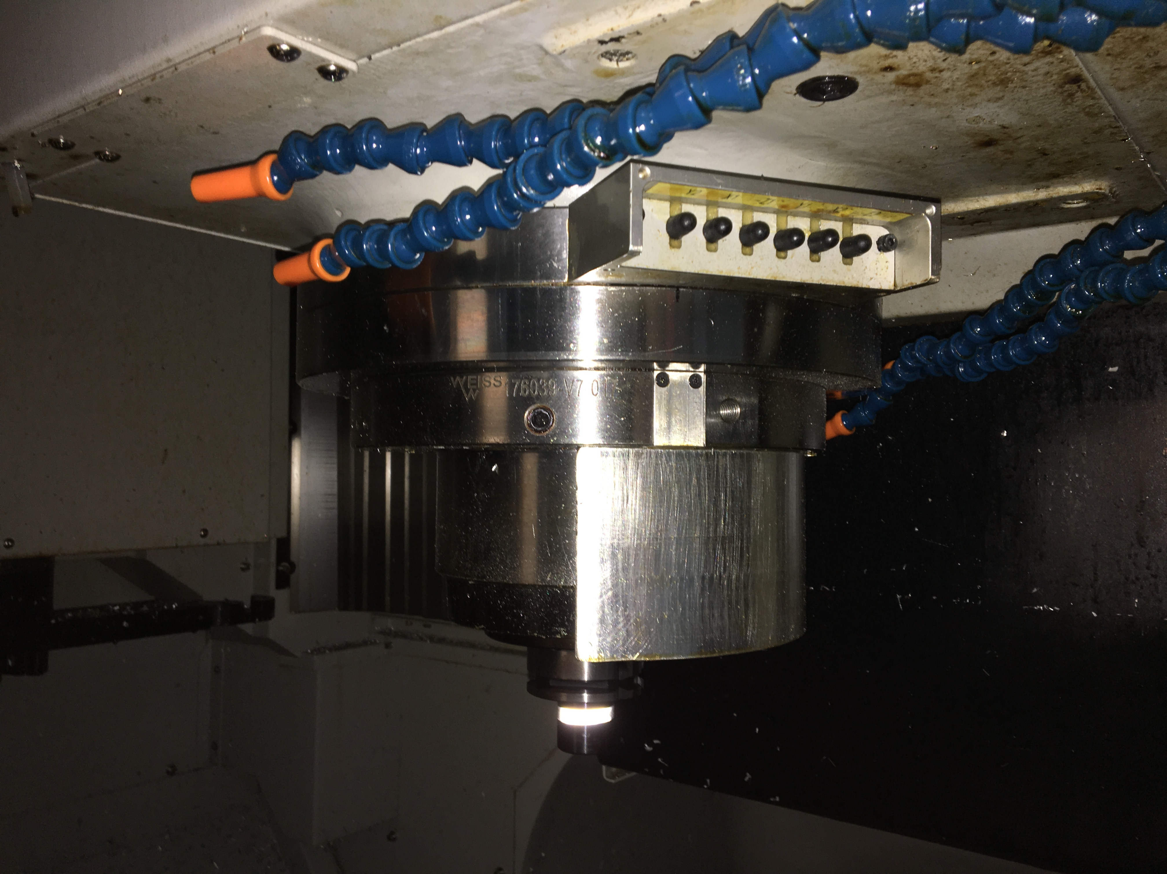

 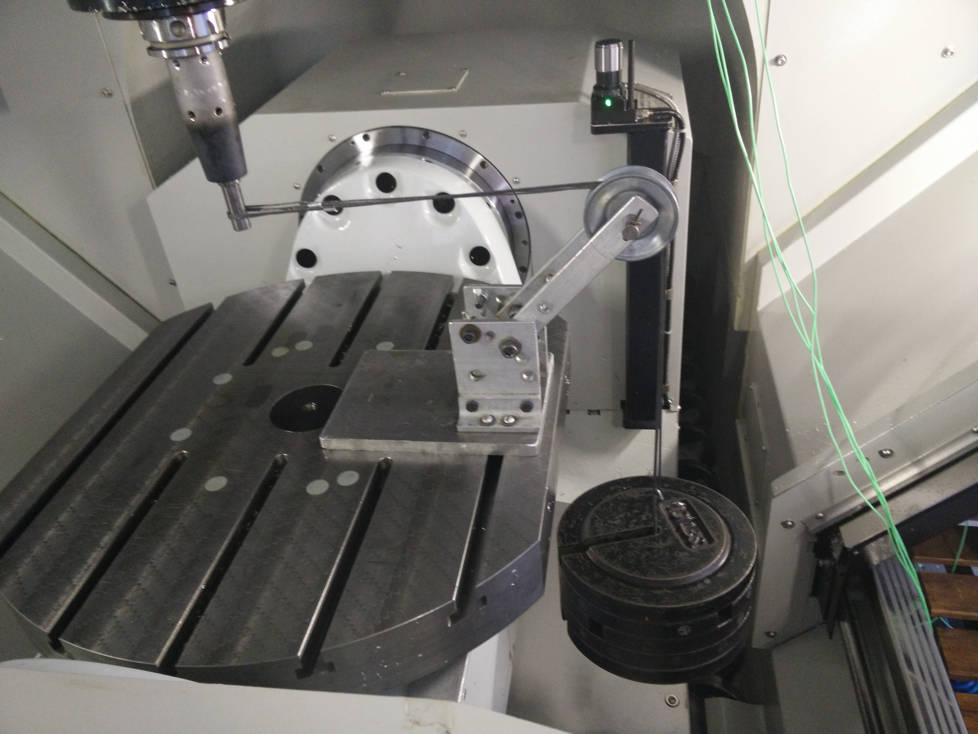



Figure Force ring with 6 Kistler Piezo Electric Slim Line Sensors installed on he spindle.