Project Interim Progress Report
(Rapport d’avancement de project intérimaire)
February 1 – June 30, 2017
Please submit by April 28, 2017
(Attn: Joanne O’Connor management@nserc-canrimt.org)

Instructions
This progress report, updated milestones and the Form 300 are required as a condition of research funding support from the sponsors of the NSERC CANRIMT. Please report for activity in the current reporting period only.

SUMMARY

THEME I : Digital Machining |  |  |  |  |  | Leader/ Chef:  (Erkorkmaz, Waterloo)
PROJECT I.A.3: Dynamics of Multi-point Threading of Thin-walled Oil Pipes |  |  |  |  |  | Leader/ Chef:  (Y. Altintas, UBC)
PROJECT DURATION/DURÉE DU PROJET : July 1, 2016 to April 30, 2020
STATUS/STATUT: (Milestones to be updated by each Project Leader)
Ahead of Schedule | X | On Schedule |  | Delayed |  |  | Cancelled

PROJECT DESCRIPTION/ DESCRIPTION DU PROJECT
(Brief description in point form, including role of project in Theme.)
The dynamic model of threading flexible oil and gas transportation pipes will be studied. The radial vibrations of a pipe’s shell modes will be projected in the direction of chip thickness at each point along the cutting edge. Having discretized chip elements, as developed in, the dynamic cutting force will be calculated for each chip element. Local dynamic cutting and process damping forces will be projected back to the cutting insert coordinates, and summed up over the entire insert. At each axial slice along the pipe, the circumference will be divided into a number of nodes. The system dynamics will be modeled as a set of coupled, delayed differential equations in modal space, and solved numerically in the semi-discrete time domain.

PROJECT OBJECTIVES & METHODOLOGY/ OBJECTIFS DU PROJET & MÉTHODOLOGIE
(Include alignment with Network objectives.)
The proposed model will lead to the prediction of vibration marks on the thread surface, which will allow for the quality of threads to also be predicted, and chatter-free optimal cutting conditions will able to be selected in a virtual process planning environment.

1. RESEARCH TEAM/ ÉQUIPE DE RECHERCHE
(Summary for the current reporting period)
1a: Research Personnel (Supervisors, Co-Supervisors, Collaborators)/
Personnel de recherche
Name, given name/  Nom., prénom | Organization/  Organisation | Sup./Co-Sup./  Collaborator | E-mail/Courriel | Phone No./  Téléphone
Altintas, Yusuf | UBC | Supervisor | altintas@mech.ubc.ca | 604-822-5622
Tamsaver, R.A. | Tenaris Tamsa | Collaborator | tamaar@tamsa.com.mx | 229-989-4448

1b: Students, Postdoctoral Fellows, Research Assist./
Assoc./Eng., Technical/Professional, Guests (from outside Province; from outside Canada)/
Étudiants, Boursier de recherches postdoctorales, assistants, techniciens et invites (invite hors Province; hors Canada)

Name, given name/  Nom., prénom | Position | Organization/  Organisation | Name/Nom.  (S) or /ou (C)* | Start/  Début | End/ Fin | CANRIMT Salary/Mo  incl ben. | Extern.  funding  amount | Extern  funding  source
Rezayi Khoshdarregi, Mohammad | PhD Candidate | UBC | Yusuf Altintas (S) | July 1, 2016
*(S) – Supervisor
(C) – Co-Supervisor

TOTAL # | BASc | MASc/  M.Eng. | Ph.D. | PDF | Res. Asst. | Res. Assoc. | Res. Eng. | Tech./ Prof. | Guests/  outside Province | Guests/  outside Canada
 |  |  | 1

1c: Partners & Contributions/
Partenaires et Contributions

Organization /  Organisation | Acronym/  Acronyme | Contact | Cash/  Espèce | In-Kind/ Nature | Overhead/  Frais généraux | Total
Tenaris Tamsa |  | Tamsaver, R.A. | $75,000 | $25,000 | $25,000 | $125,000

2. RESEARCH PLAN FOR THE CURRENT PERIOD/PLAN DE RECHERCHE POUR
LA PÉRIOD ACTUELLE (Please list both the technical objectives, methodologies and milestones as stated in the previous report.)
Analyzing the chatter experiments carried out at TAMSA and validating the developed dynamic model for threading oil pipes.

3. ALIGNMENT OF RESEARCH PROJECT WITH NETWORK OBJECTIVES/
ALIGNEMENT DU PROJET DE RECHERCHE AVEC LES OBJECTIFS DU RÉSEAU
( Please comment on the alignment of the research project with the overall Network objectives.)
Threading flexible parts such as oil pipes have not been studied before, yet it has major impact on the safety of environment and other fluid transportation applications. This project proposes a digital modeling of the complex process to avoid fatigue failure caused by chatter while improving productivity ahead of costly physical trials, which is the objective of the network.

4. PROBLEMS and RESOLUTIONS/ PROBLEMES ET SOLUTIONS PROPOSÉES
( Please summarize any problems arising during the current reporting period and their resolution or plans for resolution.)
Problem/ Problème:

Resolution / Résolution:

5. RESEARCH PROGRESS and RESULTS/ PROGRÈS DE LA RECHERCHE et RESULTATS:
(Summarize progress and results below.)
The mechanics of multi-point threading has been fully completed and published. The dynamics of the process has been formulated by investigating the chip regeneration mechanism in multi-point threading and calculating the dynamic cutting forces and process damping effect. Time-marching numerical simulation based on semi-discretization method has been developed to predict the amplitude of vibrations.
Structural dynamics and mode shapes of the oil pipes have been modelled through extensive experimental modal tests and finite element analyses. Chatter stability plots for threading oil pipes with different geometries and cutting conditions have been generated using Nyquist criterion in frequency domain, and the results are currently being analyzed against the experiments carried out at TAMSA in August 2016.

5a: MILESTONES/ÉTAPES
Summarize progress on milestones – including % completed – as outlined in the Research Plan for the current reporting period and any modifications since the last reporting period. (Milestones document also to be updated for each project.)
MILESTONE/ ÉTAPE:
Progress: Ahead of schedule
Modifications: None
% Completed/ Rempli
Milestones | % Completed/
Literature review | 100
Modal analysis of pipe and tooling support system | 100
Dynamic cutting force and process damping models, based on chip modulation | 80
Circumferentially coupled stability equations in modal coordinates | 80
Solution of vibration stability based on semi-discretization | 80
Validation of deformation and vibration predictions with experimental results | 50

5b: PUBLICATIONS and PRESENTATIONS / PUBLICATIONS ET PRESENTATIONS
Please list all publications directly arising from Network-funded research during the current period. Do not include abstracts.

A: REFEREED CONTRIBUTIONS - ARTICLES
Include articles in refereed publications – please specify whether the article has been submitted (S), accepted (A) or published (P).
Last Name, Initial | Year | Title, Journal, Volume | Status
Khoshdarregi, M.R., Altintas, Y. | 2016 | “Generalized modeling of chip geometry and cutting forces in multi-point thread turning”, International Journal of Machine Tools and Manufacture 98, 21-32 | P
B: REFEREED CONTRIBUTIONS - OTHER
Include papers in refereed conference proceedings, letters, notes, communications, review articles, monographs, books, book chapters and government publications.
Last Name, Initial | Year | Description | Status
 |  | Conference Title, Location and Date (Status: Invited, Not invited)
 |  | Journal/Book/Publication Title (Status: S-submitted; A-accepted; P-published)
C: NON-REFEREED CONTRIBUTIONS
Include papers in non-refereed conference proceedings, papers, letters and review articles.
Last Name, Initial | Year | Description
 |  | Conference Title, Location and Date
 |  | Journal/Book/Publication Title
D: SPECIALIZED PUBLICATIONS - PRESENTATIONS
Include theses, presentations, industrial/technical reports, internal reports, discussions of abstracts and symposium records.
Last Name, Initial | Year | Description
Khoshdarregi, M.R. | 2016 | “Mechanics and Dynamics of Multi-point Threading of Oil Pipes”, Veracruz, Mexico, Aug. 26, 2016. (Presentation at the collaborating company, TenarisTamsa)
 |  | Journal/Book/Publication Title
E: PUBLICATIONS –
Not originally funded by NSERC CANRIMT but continuing or completed with Network funding
Last Name, Initial | Year | Description/Title (include start date of NSERC CANRIMT funding)
F: PUBLICATIONS –
Not funded by NSERC CANRIMT but related to the Network research focus
Last Name, Initial | Year | Description/Title

5c: PATENTS and LICENSES/ BREVETS ET LICENSES
Non-disclosure agreements signed, patent applications filed, patents issued, copyrights, licenses under negotiation, licenses granted, etc.

Category | Owner | Description

5d: OTHER COMMUNICATIONS, AWARDS/ AUTRES COMMUNICATIONS, PRIX
Provide information on additional communications related to your work, such as awards and distinctions, news stories, interviews, public forums, press releases, etc. for the current reporting period (please provide copies or links.)
Name, given name/  Nom, prénom | Details | Date | Link or copy attached

6. TRAINING/ FORMATION
(Describe the extent of cross-network and partner involvement in training for the current reporting period.)
Ph.D. student visited industrial partner for two weeks, accessed to their experimental set-up which is unique, and conducted chatter tests. The company fully cooperated.

7. RESEARCH PLAN FOR NEXT 6 MONTHS/ PLAN DE RECHERCHE POUR LES 6 PROCHAINS MOIS (Describe Planned Research Activities for the next 6 month period and include any modifications made during the current reporting period.); also please list both the technical objectives and milestones.)
Cutting force and process damping coefficient of the pipe steel Tamsa used must be identified.

The effect of the shell modes of the pipe on the stability and precision of the process will be compared against experiments. We are waiting for Temsa to conduct cutting force measurement tests.

8. OPTIONAL – Comments, Questions and/or Feedback/
OPTION – Commentaires, questions et/ou des commentaires
Include any supplemental comments or questions pertaining to the Network here.

9. NETWORK EVENTS ATTENDED or SUGGESTIONS /
ÉVÉNEMENTS RÉSEAU ONT ASSISTÉ ou SUGGESTIONS

Please list any Network-related events attended and include comments and suggestions for events which may be helpful and informative for Network members to attend in future.
Event | Comments/Suggestions

Completed/Published: Generalized modeling of chip geometry and cutting forces in multi-point thread turning
A generalized model is developed to determine the chip geometry for custom multi-point inserts and custom infeed plans. A systematic chip discretization technique is developed to allow local evaluation of cutting force coefficients. Local forces on the insert are calculated using nonlinear Kinzle force model considering the effect of edge radius and varying chip thickness along the cutting edge. Element forces are projected in the machine coordinates considering the varying effective oblique angles along the edge, and summed up to determine the total forces. The model has been experimentally validated for different insert geometries and infeed plans. The chip modeling and cutting force prediction model has been released commercially as the “Threading Toolbox” in CutPro.

Paper Abstract
A generalized mechanics model of multi-point thread turning operations is presented. The cross section of the chip is determined from the thread profiles of the current and previous teeth as well as the infeed settings of the tool. The chip is discretized along the cutting edge, and the cutting force coefficients are evaluated for each element considering the varying effective oblique cutting angles and chip thickness. Nonlinear Kienzle force model is used to account for the effect of edge radius at low chip thickness values. Total cutting forces are obtained by resolving the elemental forces in the insert coordinate system, and integrating them along the engaged teeth. The experimentally validated generalized mechanics model can be used to predict the chip and cutting load distributions for multi-point inserts with custom thread profiles and infeed plans. The model can be used for both process planning and insert design.

In Progress: Dynamics of Multi-point Thread Turning (Draft of Paper Ready)
Chip regeneration mechanism for multi-point threading operations has been modeled, and the delay differential equations representing the dynamics of the process have been derived. Dynamic forces are determined by calculating the local dynamic chip thickness and process damping forces for each chip element along the cutting edge. Generalized dynamic equation of motion is formed considering three-dimensional flexibilities of the tool and workpiece. Stability of the process over each pass is analyzed in frequency domain using Nyquist criterion. The model can predict the stability of multi-point threading operations with custom inserts and custom infeed plans. Time domain multi-mode simulation has been implemented using extended semi-discretization technique to predict the amplitude of vibrations and deflections. Validating experiments were conducted on real scale oil pipes in the collaborating company (TenarisTamsa).

Figures:
Mechanics:
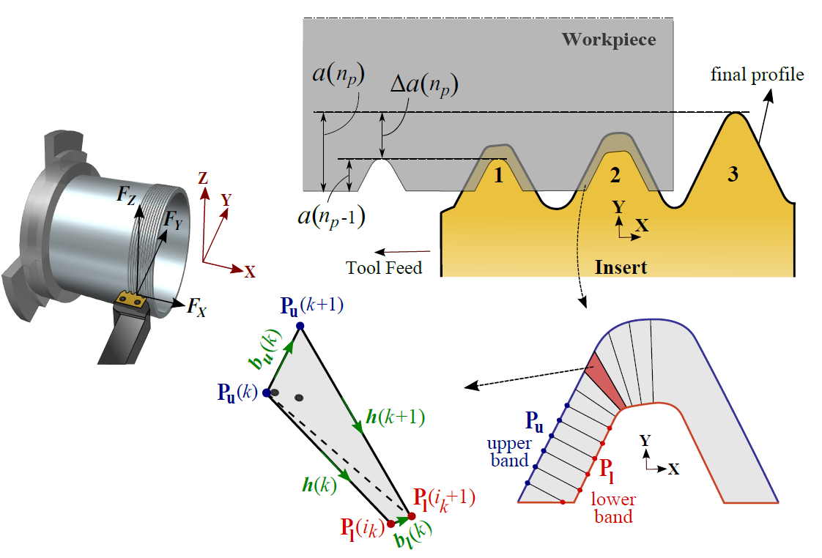
Dynamics :

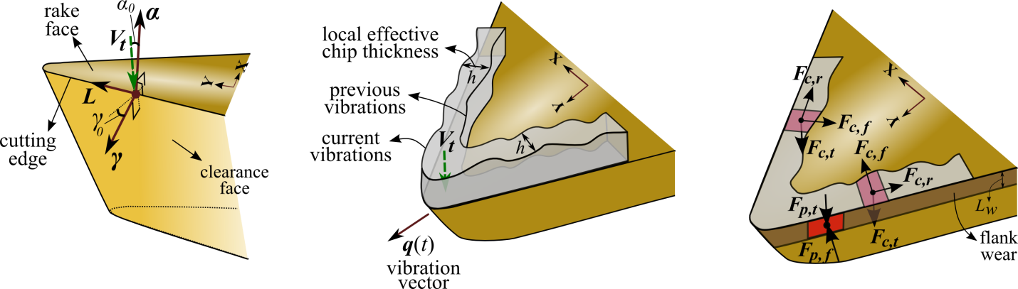

Sample Chatter Stability Analysis:
